Aim – Insert Document in database.

Learning outcome: Able to configure embedded databases with different web pages using MongoDB.

Duration: 1 hours

List of Hardware/Software requirements:

1. Laptop/Computer with Linux OS - Ubuntu 18.04 LTS
2. MongoDB 6.0.5 Community Edition

**Follow the below step’s**

* Step -1 Open the CMD/windows PowerShell.
* Step -2 Know just type **mongosh** and enter. (Here mongodsh is use to show connection between the mongoDBCompass and see below image).

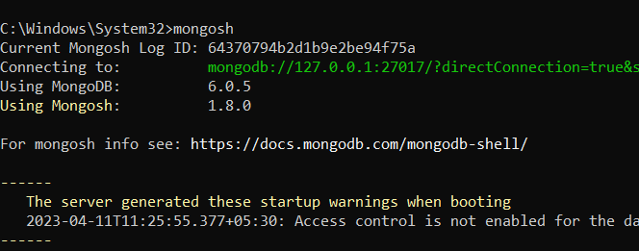

* Step -3 After the 2nd step just type the **show dbs** and enter. Here you can see all databases and they have a default database which name is test (Here show dbs is use to show the all-available databases and see below image).

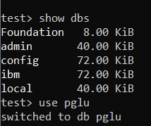

* Step -4 Type **use pglu** and enter (This CMD use for select database but upper image there don’t have any pglu database. That’s mean here we can use a new database which name is pglu but they don’t have any Documents (MySQL name -Rows) and Fields (MySQL name -Columns) let’s see the upper image and 5th step also).
* Step -5 Type **db.Emp.insertOne({name:”Payal”,salary:19000})** and enter. (This cmd use to insert only one value into the database).

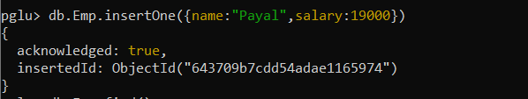

* Step -6 Type **db.Emp.find()** and enter (this cmd use to show collection and see below image).

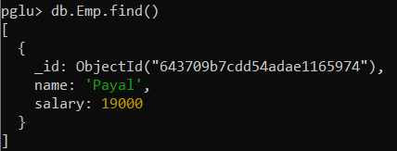

* Step -7 Type **db.Emp.insertMany([{name:"Payal",salary:19000},{name:"Priyanka",salary:25000},{}])** and enter (This cmd use to insert many values into the database see the below image).

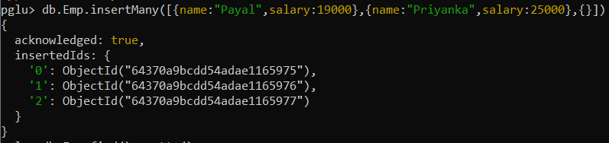

* Step -8 Type **db.Emp.find().pretty()** and enter (This cmd use to show collection same like step 6 cmd and see below image).

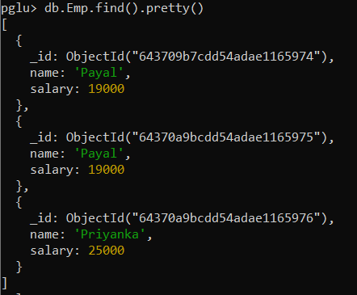

* Step -9 There we have completely insert some values. Let’s move to **mongoDBCompass** and click on connect (Remember that mongoDBCompass have a default local host no – 27017 see below image)

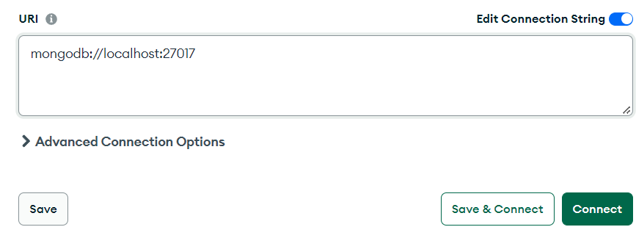

* Step -10 Let’s select **pglu** database see below image.

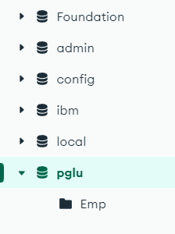

* Step -11 Know click on **Emp** collection (MY SQL name - Table) see below image.

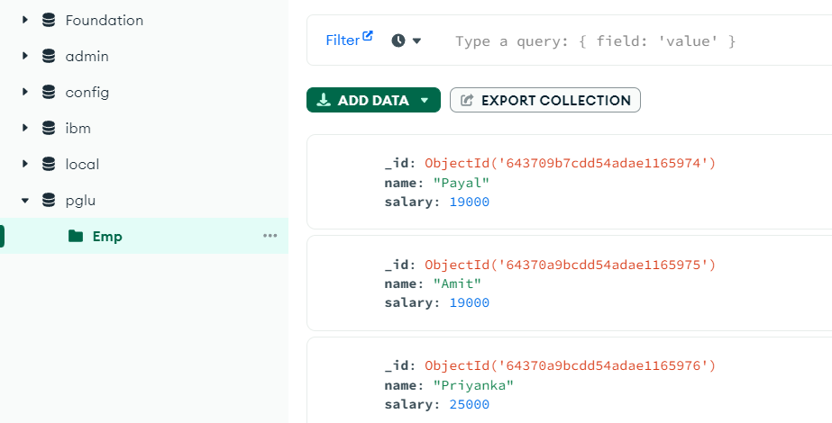

* Step -12 Click on **add data** and click on **insert documents** see below image.

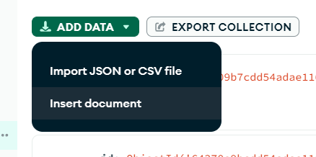

* Step -13 Then select GUI option see below image.

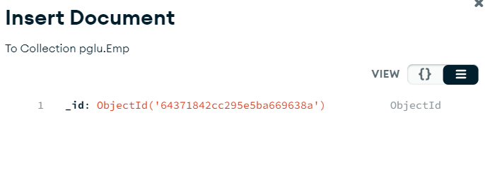

* Step -14 After 13th step click on this icon for insert the values and **add fields after _id** see below image.

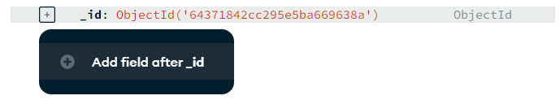

* Step -15 When you are complete 14th step then do what you want to do and here a dropdown which have all type of **data type** select with your condition and click on insert see below image.

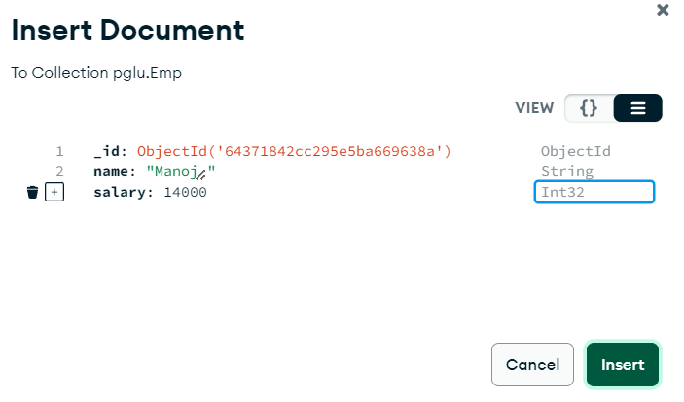

* Step -16 Then you can see you have successfully inserted a value into the **Emp** collection see below image.

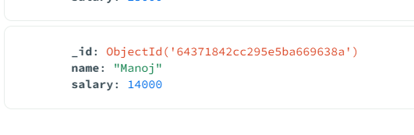

* Step -11 Let’s insert 6 more values into the emp collection.
* Step -12 We have successfully insert at least 10 values and type **db.Emp.find()** for show insert values see below image.

